create or replace procedure p_employee is

cursor c_employee is

select empid

from emplo;

begin

for i in c_employee

loop

raise_sal(i.empid,10);

end loop;

end p_employee;

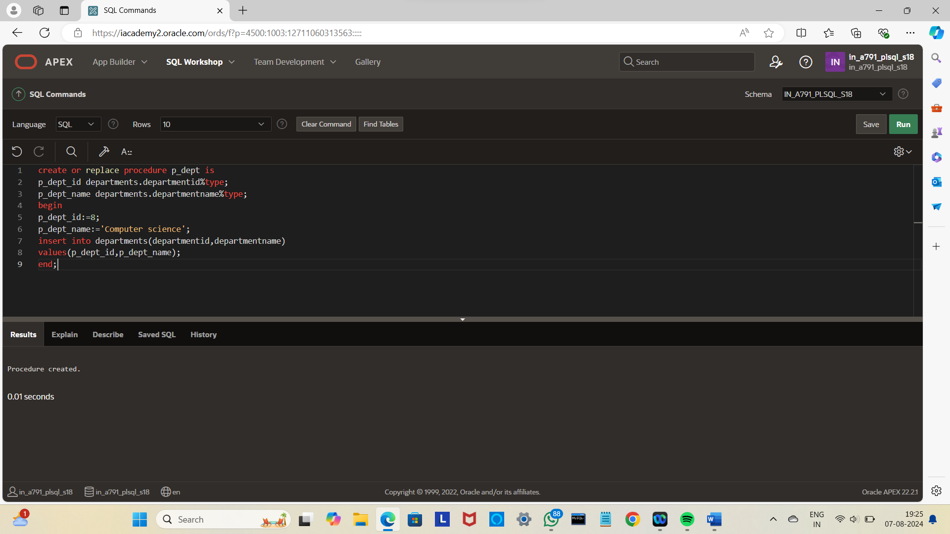

begin

p_employee;

end;

/

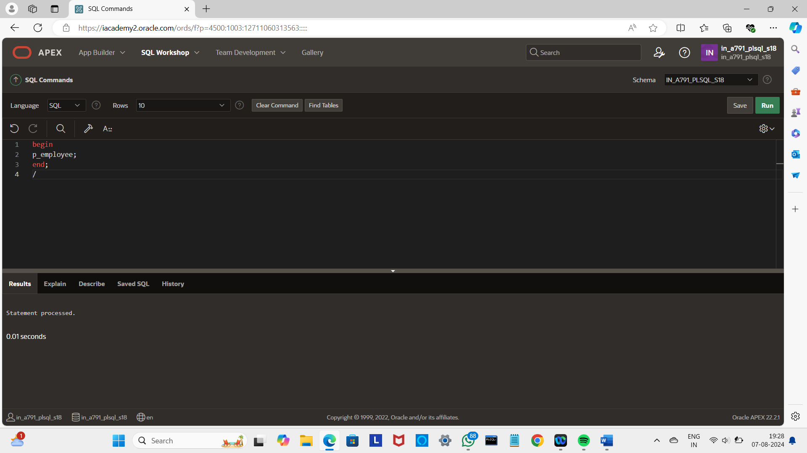

Select*from emplo;

